This form must be fully completed, signed and dated. Please state "N/A" if not applicable.
A. Visitor Profile
Name:
Address:
Tel: | Email: | Website:
B. Description ( Describe your profile )
C. Delegate Details
S. No | Name | Job Title | Email id | Contact No.
D. Visitor Registration Fee
NATTA Members | NPR 10,500/- Per Participant
Non NATTA Members | NPR 15,500/- Per Participant
Include: Hosted meals (subject to sponsorship) Invitation to Opening and Closing Ceremony, Conference during the event.
Exclude: B2B Event, Accommodation

E. Payment
Payment can be made by Cash/ Cheque / Bank Transfer, Payable to Nepal Association of Tour and Travel Agents (NATTA).

For Bank Transfer:
Account Name: Nepal Association of Tour & Travel Agents (NATTA)
Bank Name: Global IME Bank Limited,
Bank Address: Kantipath Branch, Kathmandu, Nepal
Account No.: A/C No. 0101 0100 06330
Swift Code: GLBBNPKA

For payment by bank, transfer please contact at bitmnatta2019@gmail.com with the duly completed Registration Form.

All payment must be made within a week after approval from BITM Secretariat to secure your participation.
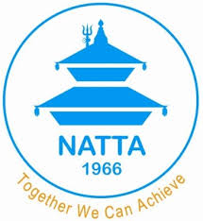 | Buddhist International Travel Mart (BITM)  Nepal Association of Tour & Travel Agents (NATTA)  Goma Ganesh, Gairidhara, Naxal, Kathmandu, Nepal.  Email: bitmnatta2019@gmail.com  Web Site : www.natta.org.np

NATTA reserves the right not to process incomplete applications.

